ScaleDB Release Management Policies

- Background

Development efforts for the Research database ScaleDB as a repository for proprietary loan- and pool-level analytics commenced in 2016. ScaleDB was promoted to a production database in February 2017. At this juncture, the Technology team took over the management of the monthly update processes for this database similar to the processes they follow for other production databases. Consequently, there is joint ownership of ScaleDB between the Research and Technology teams.

In the second phase of ScaleDB development, production applications such as Symphony and the CDU generation process began to rely on ScaleDB data.

During the second phase, monthly database updates have gone smoothly in most cases cases but there has been a lack of a formal Release Management Policy to better manage the production system, which we should have for any mission-critical database. This gap has been mitigated somewhat by the fact that there is only one environment, the production environment, for ScaleDB so the release process is relatively straightforward.

The third phase of ScaleDB began in January 2018. As we have started to support the backward compatibility of the prepayment model, the ScaleDB release is no longer that straightforward. Having a formal ScaleDB Release Management Policy has now become critical for us in order to guarantee the quality of the database, which is the basis of several key production applications.

- Objectives of the ScaleDB Release Management Policy

Release Management is the process responsible for planning, scheduling, and controlling the release build, in addition to testing and deploying releases. The ScaleDB Release Management ensures that Research and Technology team delivers the new features required by the business while protecting the integrity of the existing production system. The Policy should help us achieve the following objectives:

- Manage to handle multiple production versions (i.e., support backward compatibility);
- Reduce the number of releases with unexpected outcomes;
- Decrease the number of incidents caused by releases;
- Create a single documented process for managing all releases;
- Formalize the notion that changing any aspect of ScaleDB in terms of schema changes, adding/dropping columns, revising the calculation associated with a column etc results in a release;
- Improve coordination between Research and IT to ensure smooth and timely delivery;
- Improve productivity by establishing standard release processes;
- Standardize the process and decrease the dependency on individuals, so other team members can pick up easily;
- Harvest lessons learned from the Release Management process for the future.

- ScaleDB Release Management Policy

Key features:

- Continue to use SVN Trunk folder as the Release Management environment for next release only.
- All bundled changes (releases containing multiple enhancements/fixes) and cyclical changes must have a completed request for change (RFC) with appropriate approvals before check in to SVN Trunk folder.
- Changes to the existing production database should be bundled together and released on a regular basis (within the IT release window).
- A single “Release Engineer” must be identified for every Release. The Release Engineer will be responsible for successful coordination and execution of the Release, as well as ensuring all required documentation related to the Release exists.
- We will support two production versions simultaneously.
- Each release should be well tested and verified prior to rolling into production.
- All implementation work on the Release should be completed by the Planned End Date/Time.

- Release Workflow

The ScaleDB release workflow can be envisioned as consisting of three steps: Preparing the Release, Deploying the Release and Quality Assurance. We now describe each of these steps in detail below.

There are four types of roles involved:
- SQL developer(For example, Lien): take responsible to develop new features and provide the SQL scripts.
- Release Manager(Derek): control the check-in time, release schedule and progress in general.
- Release Engineer(Purvi): release deployment and productionalize.
- Quality Assurance(Lien): Check the general quality by look at the final production CDU.
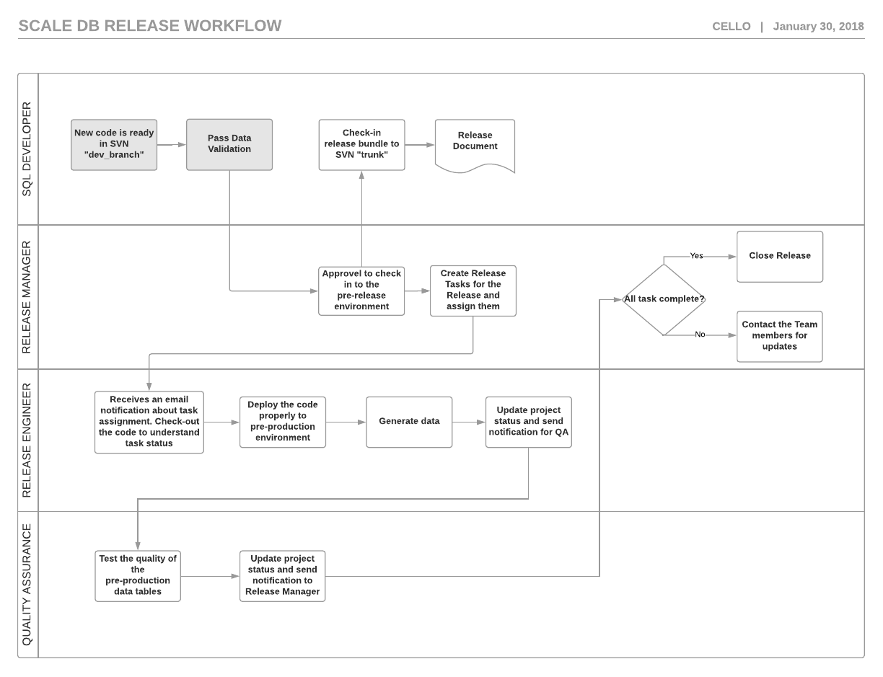

- Preparing the Release

Release Items are the details of all separate pieces of work within the Release, mostly the SQL queries. The SQL developer role is the owner of this step.

The SQL developer will need to finish the development for all the related development in the “Dev_Branch” environment. Once they feel comfortable enough to check in the code, the developer will need to notify the Release Manager and get the approval to check-in the code from “Dev_Branch” to “trunk”.

The SQL developer is also responsible for putting together the release documents, which involve two files:
- A single document that stores the information for all releases. See:
ScaleDB Release Notes - Summary
- Have a notion of each ScaleDB release if change any aspect of the database in terms of schema changes, adding/dropping columns, revising the calculation associated with a column etc.

- Deploy the Release

Once the Release Manager agrees with the request for change (RFC), the Release Engineer will be notified.

The Release Engineer will check out the latest code from SVN “trunk”, use the SVN log to get a general idea of the code update to understand the task status. Then, the Release Engineer will create the production environment to deploy the code. Also, modify the related python of job scheduler related to ScaleDB monthly update, if is necessary.

A proper deployment will be a snapshot of the “trunk” folder. The Release Engineer will take a snapshot of the production copy and put it into “Branch” in SVN. We can follow the same release folder naming convention for Scale: “S:\IT\Production\ScaleMQ\release”. After deployment, ideally, we will be able to support two production versions. And also store previous versions with the ability to be reproduced.

After deployment, the Release Engineer will need to generate the latest monthly data set as an self-testing process. Then, generate the related CDU files. Once all verified, Release Engineer can notice the Release Manager and QA to start the QA process.

- Quality Assurance

See ScaleDB Testing and Validation for a plan.

Before we have the fully implemented QA infrastructure, the Research and PM team will finish the QA on a case-by-case basis.

Once the QA is done, the Quality Assurance will notice the Release Manager with the status update. The Release Manager can confirm if the Release projection is fully finished. If so, the Manager can send out the Release Note prepared by the SQL Developer in step 1.

We do not have enough disk space to run Development and QA instances of ScaleDB at this moment.

